TAX INVOICE

# CUSTOMER DETAILS ORDER DETAILS

Name

Address

MANIAMMA

4-160,ANKIREDDYPALEM, GUNTUR,GUNTUR ANDHRA PRADESH-522005

Order No. 2-004562287363

Order Date 09-03-2025 Order Status Completed

Order Type Refill Order

**INVOICE DETAILS**

|  |  |  |  |
| --- | --- | --- | --- |
| Tax Invoice No. | 5-1049963060 | Consumer No. | 7533438292 / 7500006343829 |
| Tax Invoice Date | 11-03-2025 | Connection Type | Double Bottle Connection |
| Distributor Serial No. | 117367253100385428 |  |  |
| Consumer Category | Domestic |  |  |

|  |  |  |  |
| --- | --- | --- | --- |
| **Product** | **Quantity** |  | **Price** |
| **14.2 Kg LPG Cylinder - Filled** | **1** | Price | 786.11 |
| [CGST@2.5%](mailto:CGST@2.5) | 19.65 |
| [SGST@2.5%](mailto:SGST@2.5) | 19.65 |
| Final Price (Rs) | 827.56 |

**This is a computer-generated document and needs no signatures. **Net Due(*Amount Payable** 827.56

**includes Delivery Charges)**

***Quota:*** *113.6 Kg of Quota 170.4 Kg*

***Advance Loan (Rs.):*** *₹435.00*

***Note:***

* Subsidy amount will be transferred to Bank A/c linked to Aadhaar XXXX XXXX 0997

"Your Safety is our Priority". In case of Emergency call 1906. Customer Service Cell: 011-23412268 Suraksha Hose replacement due, eKYC due, contact distributor

For any Complaints/Queries call: 1800-233-3555 (TOLL-FREE). Now Book and Pay online through IndianOil One mobile app or https://cx.indianoil.in portal

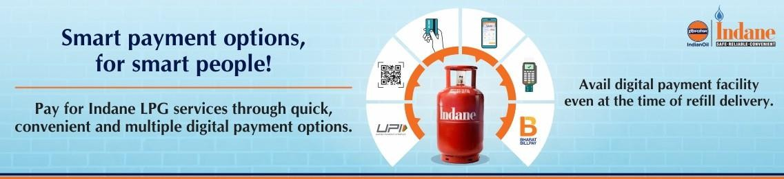

# IMPORTANT IMFORMATION

1. We have with us a varied range of non-fuel products - LPG stove, cooking appliances and other products at competitive prices.
2. It is not obligatory for customers to buy LPG stove, cooking appliances and other products only from us.
3. While buying LPG stove from outside source, please ensure that the same bears BIS mark.
4. Domestic LPG cylinder is meant for domestic cooking purpose only. The cylinder should not be sold, repaired, hypothecated, transferred or shifted to anyone or any other address without prior intimation to distributor.
5. Always insist for Pre-Delivery Check (PDC) by the deliverymen at the time of refill delivery for your safety:
   1. Delivery boy to open the seal in front of you and check the cylinder for defect/leakage.
   2. Please get the cylinder checked for correct weight.
6. Kindly provide your feedback in feedback link received through SMS.
7. Get the cylinder checked/serviced only by our authorized delivery personnel/mechanic and not by any outsider.
8. In case of any accident involving LPG installation, customers must intimate Indane distributor immediately. We have taken 3rd party insurance cover for loss of life/property in case of accident caused primarily by leakage of LPG. However, in case of intimation after 90 days from the date of accident, no insurance claim shall be entertained as per Public Liability Insurance Policy taken by Oil Companies.

# SAFETY TIPS

1. Keep cylinder in upright position only and always below the level of LPG stove.
2. Replace non-standard hose including green tube with Suraksha LPG Hose (IS 9573 type 2) available with your Indane distributor.
3. The life of Suraksha LPG Hose is 5 years and the manufacturing date is mentioned on the hose. Change Suraksha LPG Hose every five years or earlier if damaged. Switch off the regulator when not in use.
4. While changing the cylinder or servicing the appliances, extinguish all open flames in the kitchen and keep windows open.
5. If you smell LPG, check whether regulator is switched off. Do not switch ON/OFF any electrical equipment as it may cause a spark. Call 1906 or contact your distributor.

